Railway/Highway At-Grade Crossing Surface Management: An Overview
Brett R. Malloy¹ , Jerry G. Rose²

¹ Integrated Engineering, Lexington, KY
² Department of Civil Engineering, University of Kentucky, Lexington, KY

An ideal railway/highway at-grade crossing is designed to fulfill its primary purpose of establishing a smooth surface while providing for the safe passage of rubber-tired vehicles across railroad tracks. Rehabilitating and/or replacing railway/highway at-grade crossings account for significant track maintenance expenses for public agencies across all levels of government and the railroad industry. However, large numbers of crossings have conventional all-granular trackbed designs that deteriorate at a more rapid rate than the adjacent trackbed and pavement. The primary cause of this deterioration is the structural pressures exerted by the combined railway and highway loadings within the shared crossing area as well as the difficulty in maintaining adequate drainage within the immediate crossing area. This jointly-used area is an expensive unit cost of the railway line and highway. State transportation agencies and railroad companies have expressed mounting interest in recent years in adopting improved trackbed crossing designs that provide enhanced structural resiliency, which in turn lengthens their service lives. This trend has spanned technology-based design parameters and crossing management techniques, with stakeholders working to identify the optimal engineering solutions to ensure that railway/highway at-grade crossing installations have acceptable long-term performances.
Several transportation agencies and organizations now provide guidelines and standards for proper design and construction techniques to use at railway/highway at-grade crossings. This report discusses guidance that has been released by organizations and publications such as the American Association of State Highway and Transportation Officials (AASHTO), the American Railway Engineering and Maintenance-of-Way Association (AREMA), the Federal Railroad Administration (FRA), the Federal Highway Administration (FHWA), and FHWA’s Manual on Uniform Traffic Control Devices (MUTCD), as well as several states. This review focuses on administrative regulations and state statutes that inform the renewal of railway/highway at-grade crossings. A number of states have successfully developed standard at-grade crossing management practices. Comprehensive information on crossing renewal was obtained from several states, and detailed descriptions are included of the six effective state-level programs, specifically those in Illinois, Indiana, Iowa, Georgia, Michigan, and West Virginia.

Typical Highway-Railway At-Grade Crossing
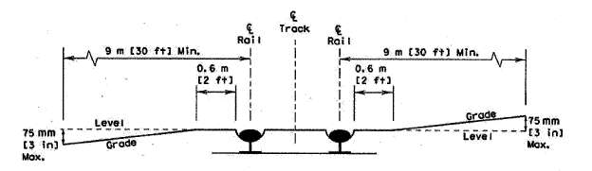
Figure 1. Alignment Specifications for Typical Highway-Railway At-Grade Crossing – AASHTO

Crossing Classified by Surface Type
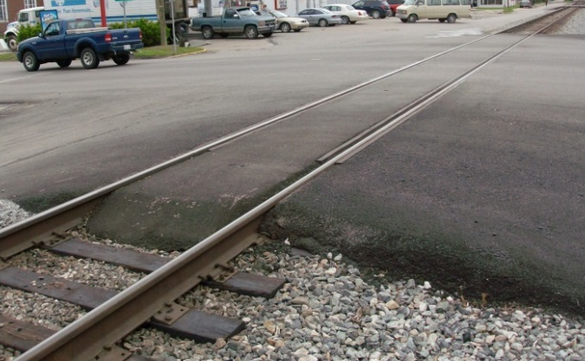
Figure 2. Typical Rubber Seal/Asphalt Crossing Surface
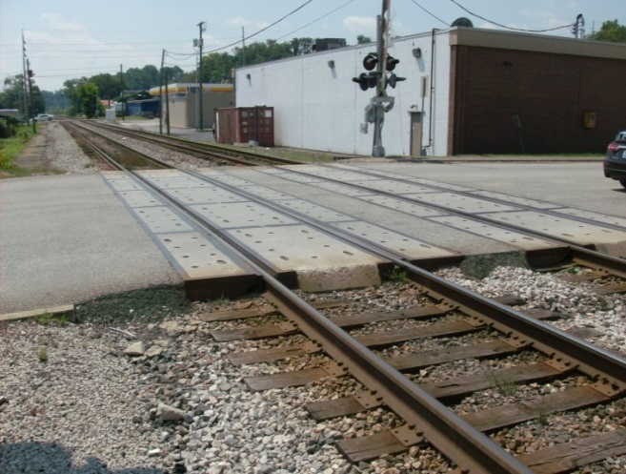
Figure 3. Typical Concrete Panel Crossing Surface
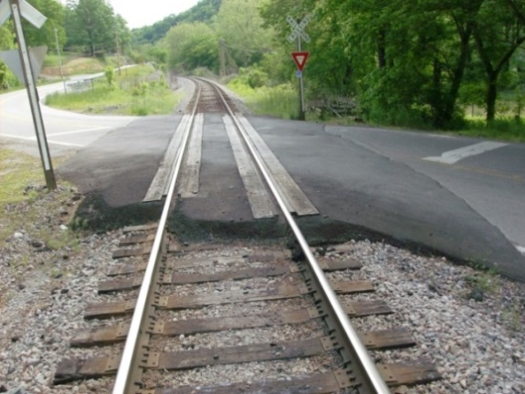
Figure 4. Typical Timber/Asphalt Crossing Surface

Figure 5. Typical Composite Crossing Surface

Summary
State transportation agencies and private railroad companies have expressed increased interest of late in incorporating asphalt underlayments and improved trackbed crossing designs and using premium materials in-lieu of traditional all-granular materials. These materials enhance the structural capability and waterproofing capacity of areas proximate to a railway/highway crossing; they will also extend the service lives of crossing surfaces. Technology-based design parameters and crossing management techniques for assessing optimal engineering solutions are now common practice for agencies responsible for crossing management and oversight. Numerous transportation agencies and organizations have issued guidelines and standards for the proper design and construction techniques for railway/highway at-grade crossings, including AASHTO, AREMA, FRA, FHWA, MUTCD, and several states. Comprehensive information was summarized for the States of Illinois, Indiana, Iowa, Georgia, Michigan, and West Virginia. These selected states have been successful in developing standard at-grade crossing management practices.

Reference
[1]. Malloy, B R., and J. G. Rose, Research Report KTC-14-17/SPR452-13-2F. “Railway/Highway At-Grade Crossing Surface Management: An Overview,” Kentucky Transportation Center, University of Kentucky, December, 2014, 62 pages.
The authors would like to thank the National University Rail (NURail) Center, a US DOT-OST Tier 1 University Transportation Center for sponsoring this study.

